Magento Backend Usage by Cell Culture:

# Sales, Orders:

* Alex (or another member of the team when she is off) checks every order to see if cell lines are ordered. This is done because we need to assign which lot of cells we will be shipping, and pull from inventory ahead of time.
  + Function to add: Notify Alex, Cindy, Justy, and Heather EVERY time a cell line is ordered, regardless of stock number. This was a function on the old website.
* When a cell line is ordered which is in stock, we determine which lot we will ship and add that information to the individual item’s notes section.
* When a cell line is ordered which is not in stock, we add it to the CSL under:
  + Alex - by default for cell lines we need to propagate. If another person will be propagating the cells, it will be transferred to them later.
  + Purchasing - if the cells need to be ordered from a supplier.
    - This works fine currently, except for the “Something went wrong” pop-up that happens when you open an order page. This pop-up also comes up after editing the individual item notes section.
* If an order includes live cell shipment, it will be added to the CSL under Alex. If we need to purchase items to culture the cells, we notify order team about the delay. Otherwise, order team needs to notify us when the customer is ready to receive shipment, and then we arrange thawing the cells and scheduling shipment date.
  + This system is working well for my team.
* Function to add: Button to view order on the CSL/bring up any items on the order on the CSL. This was a function on the old website.  
  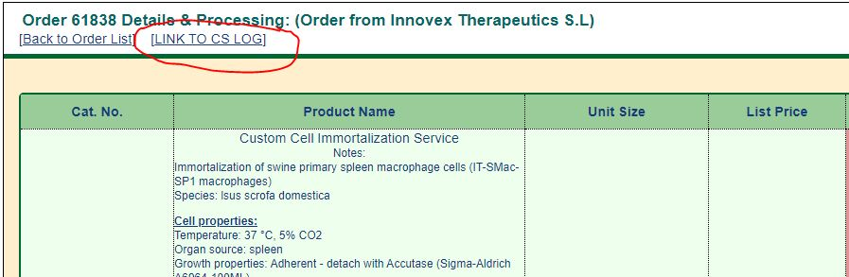
* Function to add: When items reach 0 on the backend, send out a notice. Right now we only get notified when items are less than 0.

# Catalog, Products:

* Alex uses to:
  + Remove/Add/Update missing/incorrect information for cell product descriptions
    - Due to the instability of the website, this can only be done for information that is only visible on backend at this time.
    - Going forward, I need the ability to edit the website descriptions, including uploading and deleting cell lines without the website breaking down. The cell line catalog is always being added to, and we consistently need to update/fix website descriptions.
* Cindy uses to:
  + Update inventory number & location for cell lines and lentivirus products
    - Which section the Inventory Location information is under is inconsistent between products, sometimes it is under Classification System and sometimes it is under Content. Suggest moving up to the top section of the Product editing page (closer to Quantity).

# Catalog, Faqs:

* Remove/Add/Update missing/incorrect information for cell product descriptions (Alex only)
  + Again, due to the instability of the website, I am not able to edit these at this time. This should be resolved.
  + Recommend adding a function to search the Faqs by SKUs that the Faqs appear on

# Catalog, References:

* Remove/Add/Update missing/incorrect information for cell product descriptions (Alex only)
  + Again, due to the instability of the website, I am not able to edit these at this time. This should be resolved.
  + Recommend adding a function to search the References by SKUs that the References appear on
  + If there isn’t a function to mass upload References, recommend adding it, as we have a lot of missing references for cell lines which need to be added in the future.

# Custom Service, Order List:

* Updating item status
  + No issues other than the inconvenience of having each item open into a new window. Please change it so that they open in the same tab.
* Checking to see if an item is complete (when preparing shipping lists)
  + As mentioned in the Sales, Orders section, having a link to the CSL for a particular order when looking at the order list/individual order would make this easier.
  + From the CSL view, the linked Order numbers only work if you right click and select ‘Open in new Tab/Window’. It would be easier to use if you could click and have it open in the current tab.  
    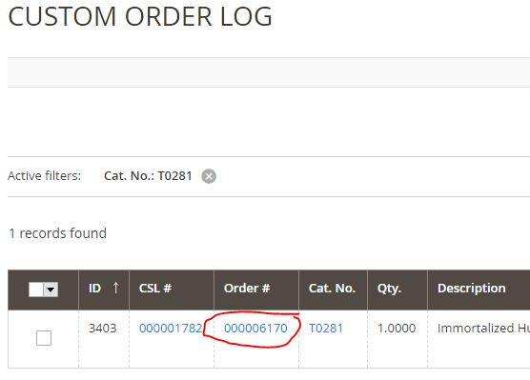

Recommended Changes to Product Descriptions (General)

* Finding the various fields of information is confusing, as it can be different between Attribute Sets/product types
  + For example, sometimes the description is under Content, and other times it is under Datasheet
    - Recommend changing the layout of the description viewer such that sections where description fields are located (Content vs. Datasheet vs. Classification and System) are consistent between products regardless of their Attribute Set. The drop down function for each section could be eliminated and each field could be visible immediately upon opening an individual product’s description.
* For different cell line Attribute Sets, there are different description fields, and they can appear in a different order.
  + Recommendation for new backend: Have ONE Attribute Set for all cell lines: Cell Lines. Under this Attribute Set, all description fields would be available for information, but if they are empty, they wouldn’t appear on the frontend.
* In the Datasheet section, there are duplicated description fields (multiple for species, organ, donor information, etc.). For the new backend, recommend eliminating duplicates. I have eliminated duplicates in my “Recommended Changes to Cell Line Descriptions (Available Fields & Their Order)” section below.
* There is information on the old website that was never transferred to the new website. This includes certain sections of product descriptions that didn’t have equivalent sections on the new website (for example Features on G422), images, and references.
* If there was a way to make many updates at once, on a CSV file for example, and then upload it to the backend to update existing products, we could add missing information for many products at once. Lots of cell lines in the mass upload in September 2020 are missing the majority of their description contents, and this will need to be added at some point in the future.

Recommended Changes to Cell Lines Descriptions (Available Fields & Their Order)

* Keep existing fields in top section as-is, no issues for my team  
  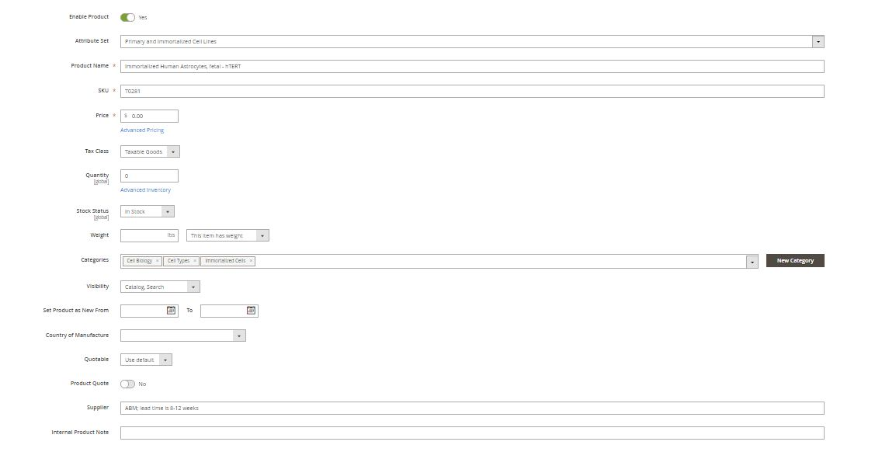
* For the Attribute Set that would apply to all cell lines (‘Cell Lines’), I recommend the following fields and for them to follow this order on the website.

|  |  |  |  |
| --- | --- | --- | --- |
| **Order** | **Field Name** | **Field Type** | **Front-End Visibility** |
| **\*move to the top section - this is updated regularly! Recommend this change for other product types as well.** | Inventory Location | Text | Not visible |
| 1 | Species | Drop down list | Visible |
| 2 | Tissue/Organ/Organ System | Drop down list | Visible |
| 3 | Cell Type | Drop down list | Visible |
| 4 | Donor Gender | Drop down list | Visible |
| 5 | Donor Age | Text | Visible |
| 6 | Donor Ethnicity | Text | Visible |
| 7 | Donor Disease | Text | Visible |
| 8 | Growth Properties | Drop down list | Visible |
| 9 | Cell Morphology | Drop down list | Visible |
| 10 | Seeding Density | Text | Visible |
| 11 | Population Doubling Time | Text | Visible |
| 12 | Immortalization Method | Text | Visible |
| 13 | Mammalian Selection Marker | Drop down list | Visible |
| 14 | Expression Profile | Text (with Editor) | Visible |
| 15 | Pharmaceutical Target | Drop down list | Visible |
| 16 | Description | Text (with Editor) | Visible |
| 17 | QC | Text (with Editor) | Visible |
| 18 | Propagation Requirements | Text (with Editor) | Visible |
| 19 | Freeze-Thaw Recovery | Text (with Editor) | Visible |
| 20 | Subculture Protocol | Text (with Editor) | Visible |
| 21 | Preservation Protocol | Text (with Editor) | Visible |
| 22 | Unit Quantity | Text | Visible |
| 23 | Licensed From | Text | Visible |
| 24 | Biosafety Level | Drop down list | Visible |
| 25 | Applications | Text | Visible |
| 26 | Disclaimer | Text (with Editor) | Visible |
| No preference for order of these fields | Invisible Search Keywords | Text | Not visible |
| Licensed By | Text | Not visible |
| Licensing Institution | Text | Not visible |
| Licensor Name | Text | Not visible |
| Licensor Commission Rate | Text | Not visible |
| Royalty Rates | Text | Not visible |
| Licensor Contact Information | Text | Not visible |
| Contract Termination Date | Text | Not visible |
| sn | Text | Not visible |
| csn | Text | Not visible |
| csn Value | Text | Not visible |
| ssn | Text | Not visible |
| ssn Value | Text | Not visible |
| dsn | Text | Not visible |
| Operator | Text | Not visible |
| Source CatNo | Text | Not visible |
| Source Price | Text | Not visible |
| Supplier General | Text | Not visible |
| China Pricing | Text | Not visible |